Creating Safari Web Push Certificate
Before we begin, ensure you have an active paid Apple Developer subscription to create a unique Push ID for your website. The entire process can be divided into four sections:
- Creating a Certificate Request (CSR)
- Setting up a Website Push ID
- Generating the Web Push Certificate
- Hosting the push package and integrating it into your app
Note: With Safari 16 running on macOS Ventura (13) or later, the Web Push Certificate is no longer required. Apple now uses the standard Web Push API, aligning Safari with browsers like Chrome and Firefox. For Safari 15 or earlier, the web push certificate is still required for permissions.

Step 1: Create a Certificate Request (CSR)
We will create a Certificate Signing Request (CSR) using the Keychain Access app.
- Launch Keychain Access.
- Navigate to: Keychain Access > Certificate Assistant > Request a Certificate From a Certificate Authority.
- 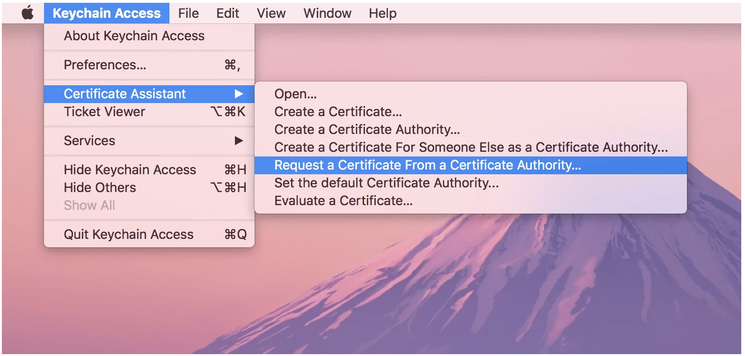
- Enter your email address and name.
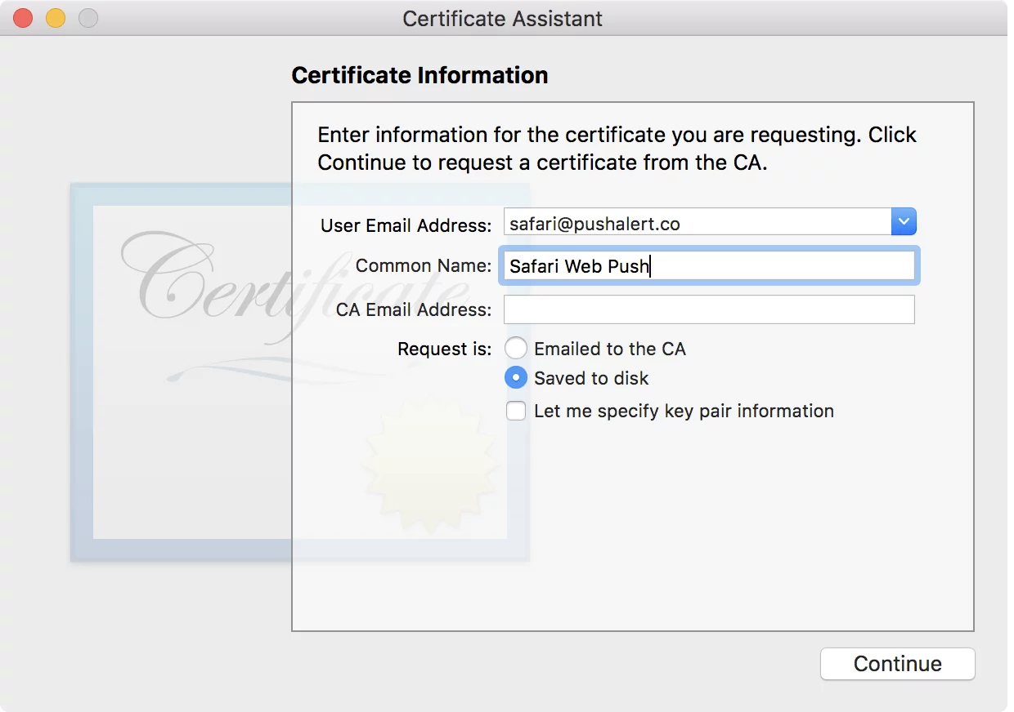
- Select “Saved to disk”, then click Continue.
- Save the generated .certSigningRequest file. You will need this in later steps.

Step 2: Set Up Website Push ID for APNS
Now we create a unique Website Push ID for Apple Push Notification Service (APNS).
- Log in to the Apple Developer Console, and go to Certificates List
- Go to Identifiers → Register an App ID.
- Select Website Push IDs from the “Register a New Identifier” list, then click Continue.
- 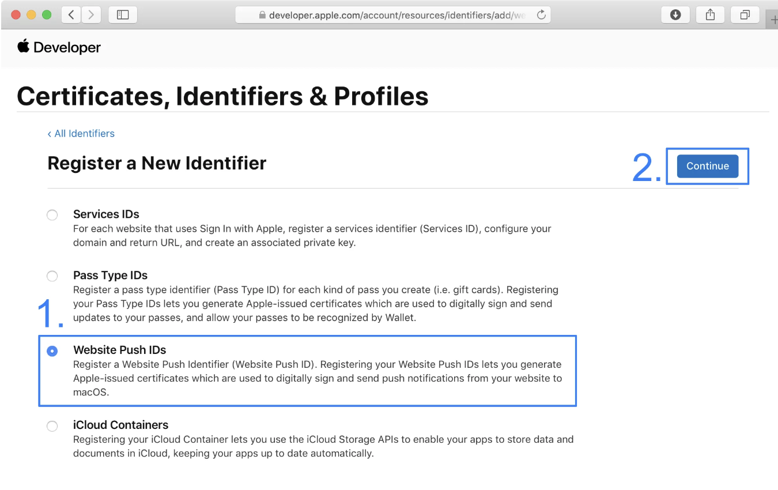
- Enter a meaningful Description.
- For Identifier, follow reverse-domain naming, e.g., web.com.mywebsite. > Note: The prefix web is added automatically by Apple.
- Click Continue, verify the details, and then click Register.
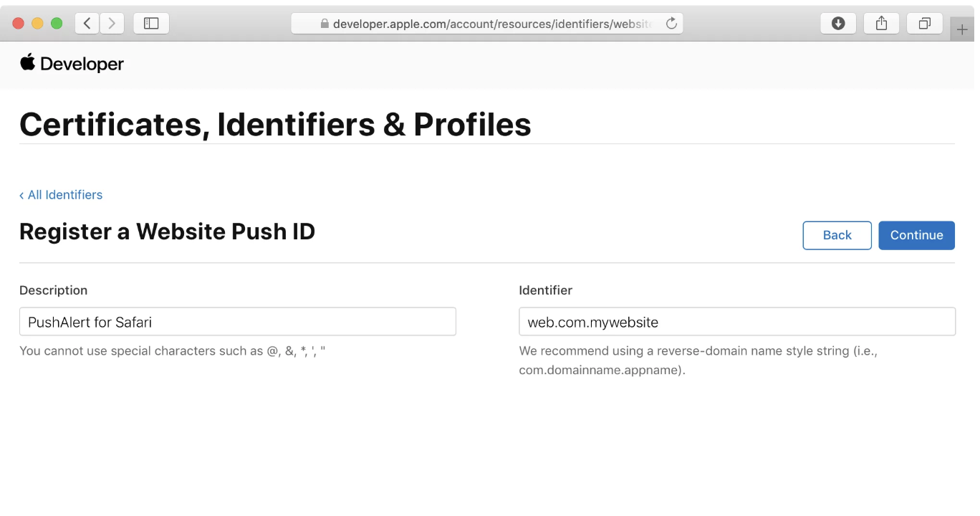

Step 3: Generate Web Push Certificate
- Go to Certificates and click the + icon.
- 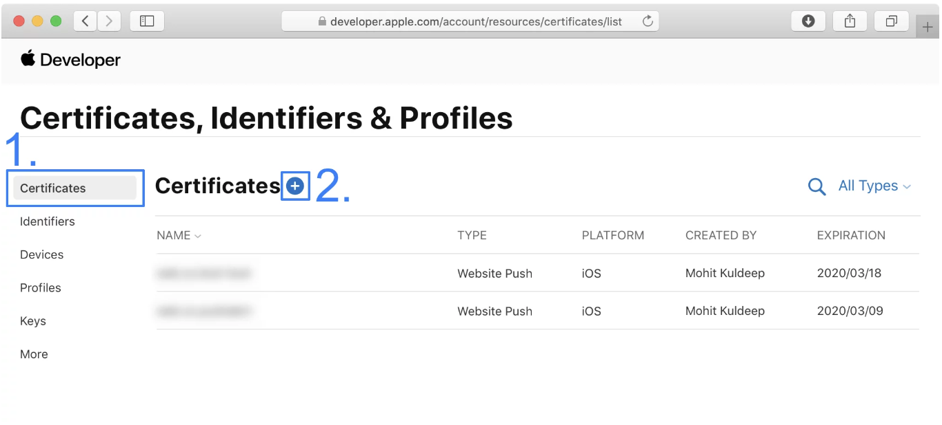
- Select Website Push ID Certificate, then click Continue.
- Choose the Website Push ID created in Step 2, then click Continue.
- 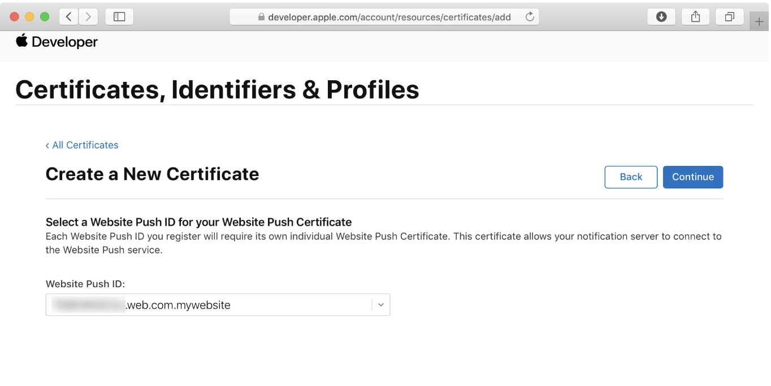
- Upload the CSR file from Step 1 and click Continue.
- 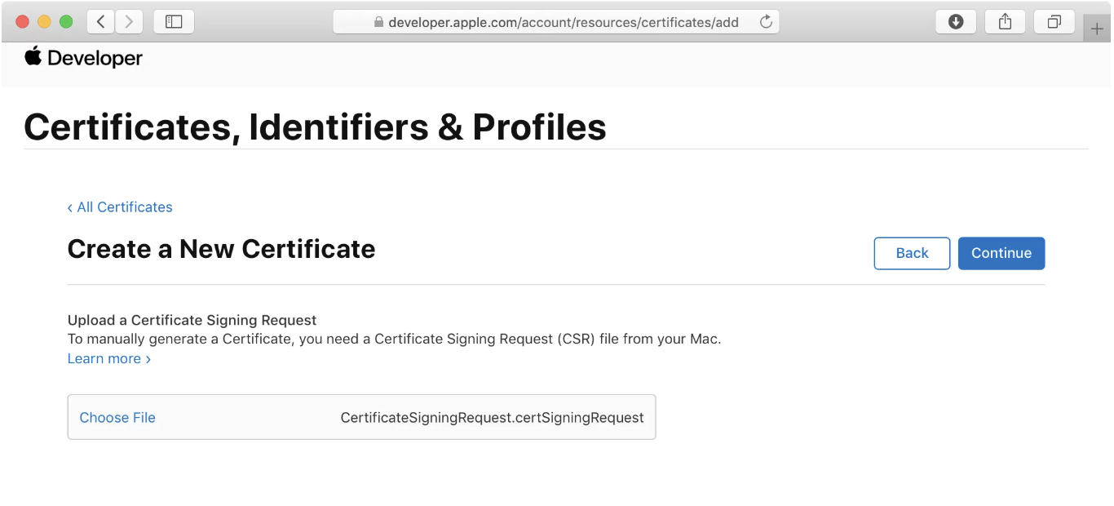
- Download the generated SSL Certificate.
- 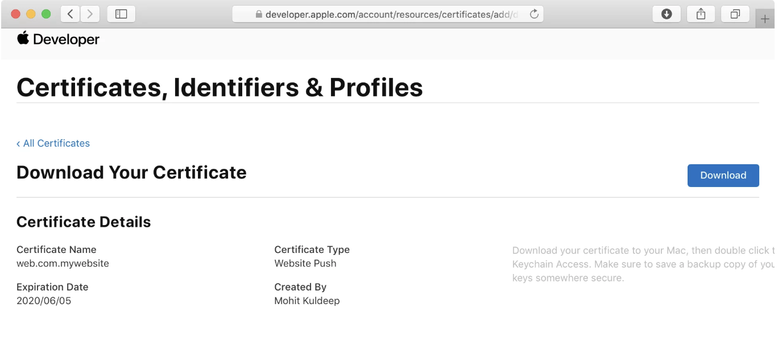
This certificate will be used to send push notifications to subscribers.

Export the Certificate (.p12)
- Double-click the downloaded certificate to install it in Keychain Access.
- In Keychain Access, select Certificates under the Category section.
- Right-click the certificate associated with your Website Push ID and choose Export.
- 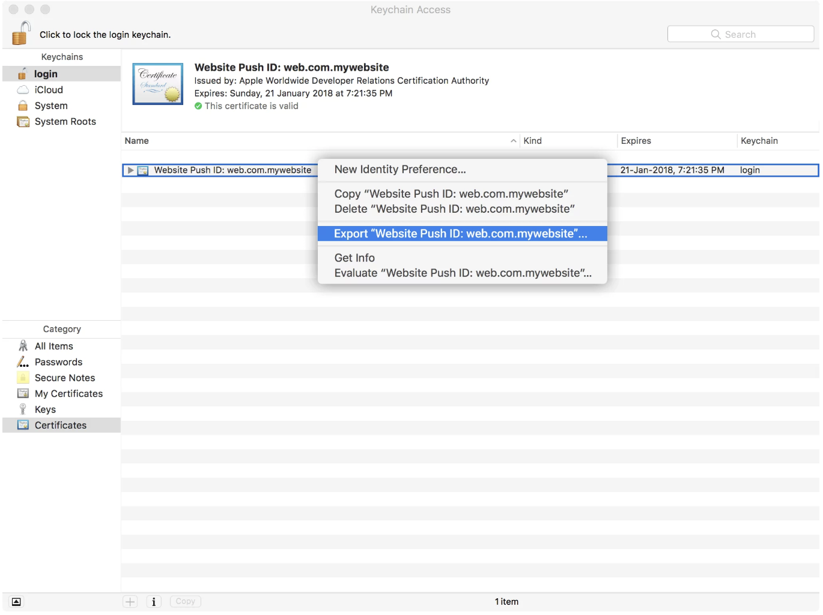
- Save it as a Personal Information Exchange (.p12) file.
- 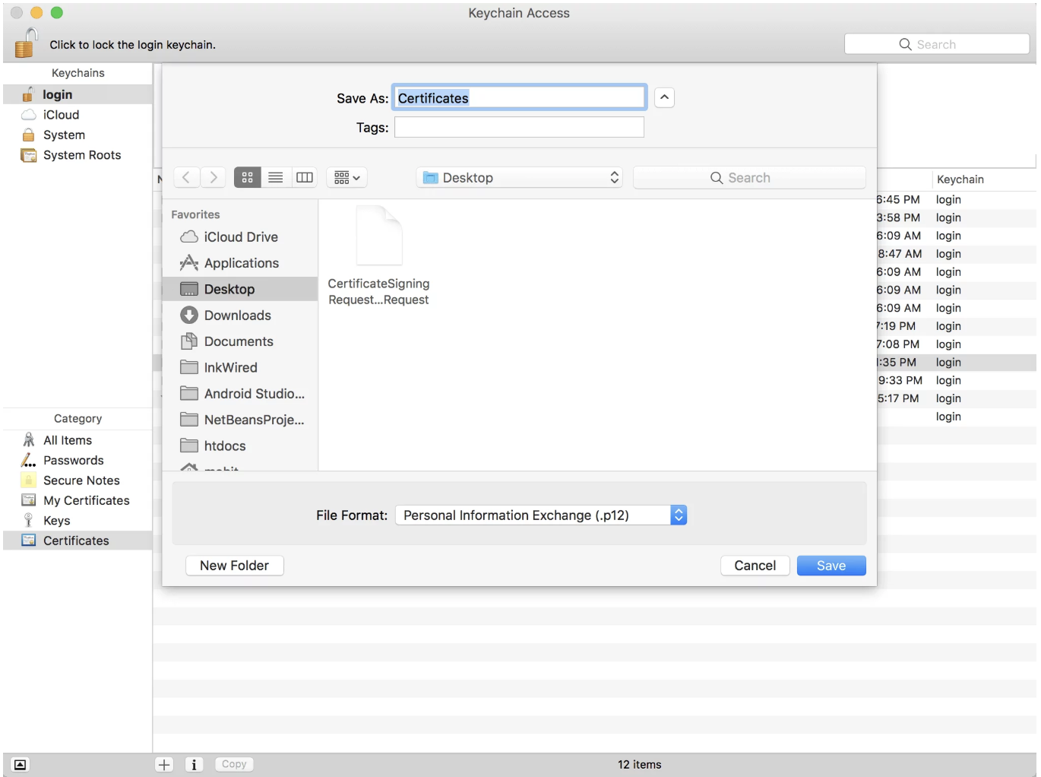
- When prompted for a password, leave it blank and click OK.
- 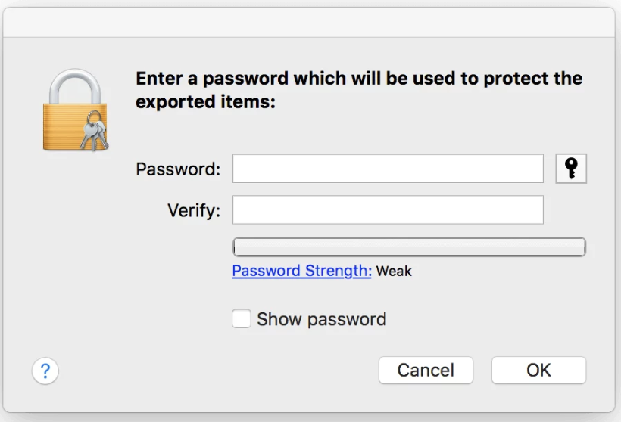
- Click Allow and enter your Mac password to complete the export.
- 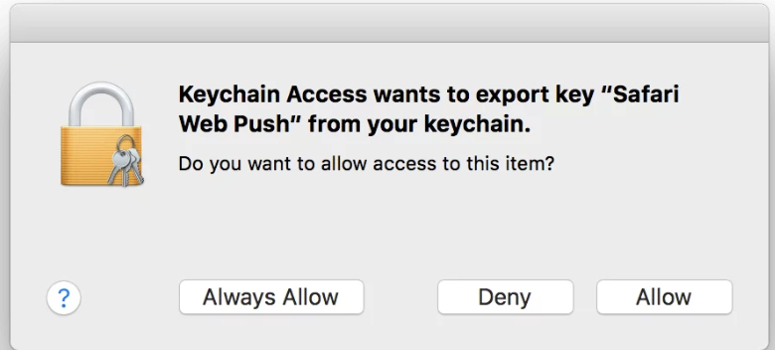
You now have your .p12 certificate ready to upload or use.

Step 4: Create and Host the Push Package
You can now proceed with creating a push package using Apple’s official PHP companion file.

Requirements
- PHP 7.4.33 installed locally
- OpenSSL (built-in on macOS)

Installing PHP 7.4 via Homebrew
brew tap shivammathur/php
brew install shivammathur/php/php@7.4
Verify installation:
brew list | grep php
php -v
If php -v doesn’t work, add it to your PATH:
export PATH="$(brew --prefix php@7.4)/bin:$PATH"

Download the Companion Script
From Apple’s documentation, download the companion PHP file (link available at the top right of the page).
This package includes createPushPackage.php, which builds the .zip push package. However, use the companion file in the code repo to generate the push package as there is a difference in create_signature function compared to what is provided by the apple developer script.

Re-export or Repackage Your .p12 Certificate
If your .p12 certificate uses RC2 encryption, you must re-export it using AES instead.

Convert Using OpenSSL
# Step 1: Extract using legacy mode
openssl pkcs12 -legacy -in ReelQA.p12 -out temp.pem
# Step 2: Repackage with AES encryption
openssl pkcs12 -export -in temp.pem -out ReelQA_AES.p12 \
-name "Website Push ID: web.com.reelqa" \
-certpbe AES-256-CBC -keypbe AES-256-CBC

Create the Push Package
php createPushPackage.php > pushPackage.zip
unzip -l pushPackage.zip

Step 5: Integrate Push Permission in Your App
Finally, enable Safari Push in your web app. Add a Call-To-Action (CTA) to prompt users for notification permission.
Here’s an example React component:
export default function PushNotification() {
const { t } = useTranslation('translation', { keyPrefix: 'Common' });
const [anchorEl, setAnchorEl] = React.useState<HTMLButtonElement | null>(null);
const [permissionData, setPermissionData] = useState<any>(
window.safari.pushNotification.permission(`${process.env.WEB_PUSH_ID}`),
);
const [showIcon, setShowIcon] = useState<boolean>(
window.safari.pushNotification.permission(`${process.env.WEB_PUSH_ID}`).permission === 'default',
);
const handleClick = (event: React.MouseEvent<HTMLButtonElement>) => setAnchorEl(event.currentTarget);
const handleClose = () => {
setAnchorEl(null);
setShowIcon(false);
};
const handleSafariPermission = () => {
checkRemotePermission(permissionData);
};
const checkRemotePermission = (permissionD: any) => {
if (permissionD.permission === 'default') {
window.safari.pushNotification.requestPermission(
`${process.env.API_URL}notification-service/reel/api/v1/apns`,
`${process.env.WEB_PUSH_ID}`,
{},
checkRemotePermission,
);
} else if (permissionD.permission === 'denied') {
setShowIcon(false);
setPermissionData(permissionD);
handleClose();
} else if (permissionD.permission === 'granted') {
setShowIcon(false);
setPermissionData(permissionD);
updateDeviceTokenForSafari(permissionD.deviceToken);
handleClose();
}
};
const open = Boolean(anchorEl);
const id = open ? 'notification-popover' : undefined;
return (
<div className="pushNotification">
{showIcon && (
<IconButton aria-describedby={id} onClick={handleClick} className="push_button" disableRipple>
<img src={Images.PUSH_NOTIFICATION} alt={t('manage_push_notifications')} />
</IconButton>
)}
<Popover
id={id}
open={open}
anchorEl={anchorEl}
onClose={handleClose}
anchorOrigin={{ vertical: 'bottom', horizontal: 'right' }}
transformOrigin={{ vertical: 280, horizontal: 'right' }}
className="notification_popover"
>
<div className="push_head">
<h3>{t('manage_push_notifications')}</h3>
<IconButton onClick={handleClose}>
<img src={Images.CLOSE} alt={t('manage_push_notifications')} />
</IconButton>
</div>
<div className="push_body">
<p>{t('push_notifications_message')}</p>
</div>
<div className="push_bottom">
<CustomButton
onClick={handleClose}
size="large"
variant="outlined"
text={t('reject')}
width="100%"
/>
<CustomButton
onClick={handleSafariPermission}
size="large"
variant="contained"
text={t('allow')}
width="100%"
/>
</div>
</Popover>
</div>
);
}

✅ Summary
You’ve now completed the Safari Web Push setup:
- Generated and exported a .p12 certificate.
- Created a Website Push ID and certificate in Apple Developer.
- Repackaged your certificate with AES encryption.
- Built and hosted the push package.
- Integrated the request permission flow in your React app.
You’re ready to send push notifications to Safari users on macOS and iOS!

